SUPPORTING DIAGRAMS & FLOWCHARTS
College Timetable Management System with Intelligent Clash Detection and Resolution
Companion Document to the Internship Project Report
Repository: github.com/Krishp285/timetable-clash-resolution

This document contains all architecture, workflow, UML, ER, data-flow, and machine-learning diagrams referenced in the main project report (Figures 1–13). Each diagram was generated directly from the system's documented design (models.py, clash_service.py, ml_clash_predictor.py, and the project README) so it accurately reflects the implemented system.

A NOTE ON SCOPE
This companion document provides the thirteen structural and behavioural diagrams — system architecture, workflow, UML diagrams, ER diagram, data-flow diagrams, and the machine-learning model diagram — that illustrate how the system is designed and how it behaves. These are accurate, source-grounded technical diagrams, not decorative artwork.
It does not include the application's UI screenshots (login page, dashboard, timetable-creation screen, etc.) listed as Figures 14 onward in the main report's List of Figures. Genuine screenshots can only be captured from the running application itself; fabricating mock UI images and presenting them as screenshots would misrepresent the actual product. To add those, run the application locally (see Appendix B of the main report) and capture each screen listed in Appendix H, or let me know and I can produce clearly-labelled wireframe mockups instead of screenshots.
Each diagram below is numbered to match its Figure number in the main report, so it can be copied directly into the corresponding location.

FIGURE 1
Referenced in: Chapter 4, Section 4.1
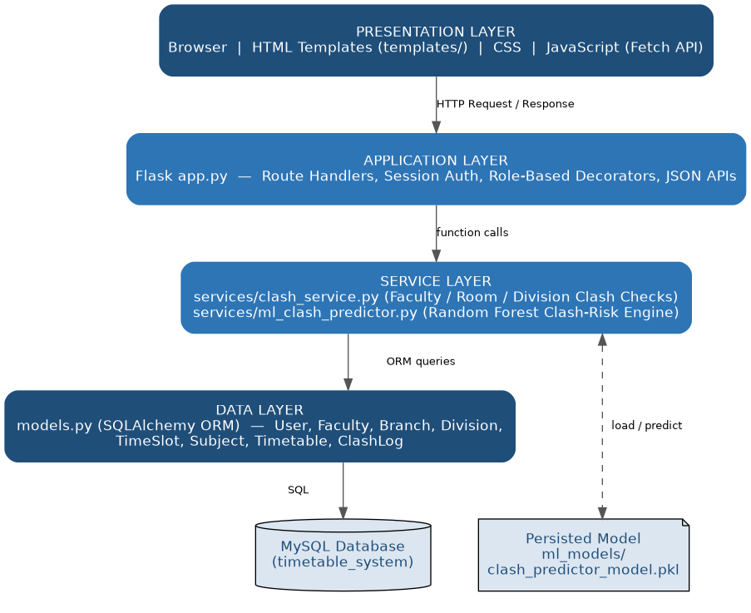
Figure 1: System Architecture Diagram
Four layers, top to bottom: the Presentation Layer (browser, HTML templates, CSS, JavaScript), the Application Layer (Flask app.py route handlers, session authentication, role-based decorators, JSON APIs), the Service Layer (clash_service.py and ml_clash_predictor.py), and the Data Layer (SQLAlchemy models mapped to the MySQL database). The persisted machine-learning model file is shown as a store accessed directly by the Service Layer.

FIGURE 2
Referenced in: Chapter 4, Section 4.2
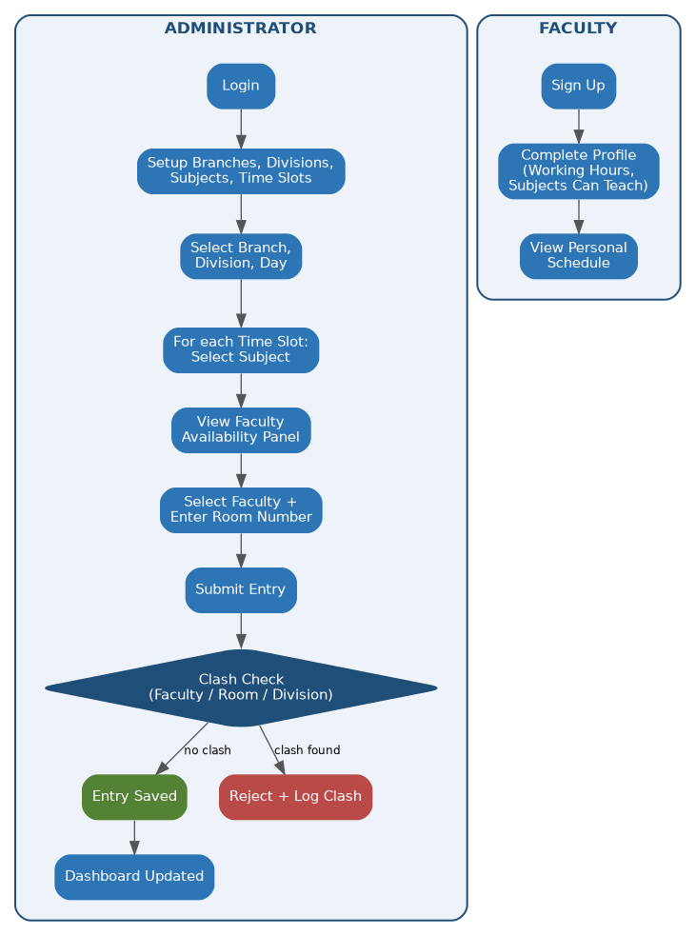
Figure 2: Overall Workflow Diagram
Two parallel swimlanes. The Administrator lane runs from login through master-data setup, branch/division/day selection, per-slot subject and faculty selection, entry submission, the three-way clash check, and dashboard update. The Faculty lane runs from sign-up through profile completion to viewing the personal schedule.

FIGURE 3
Referenced in: Chapter 4, Section 4.11
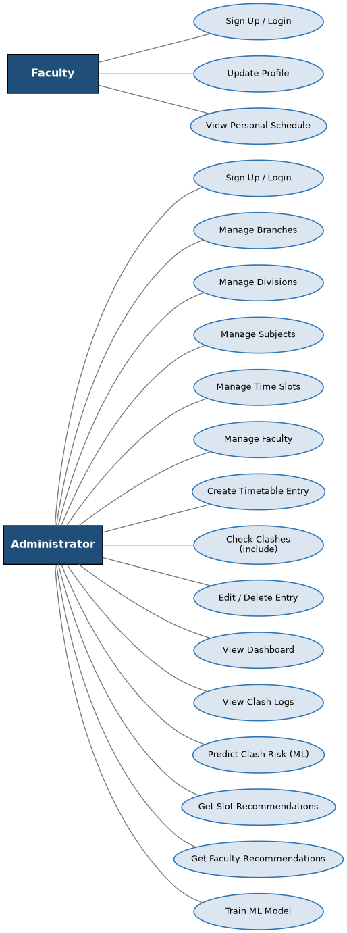
Figure 3: Use Case Diagram
Two actors — Administrator and Faculty. The Administrator's use cases span master-data management, timetable-entry creation with an included clash check, dashboard and clash-log viewing, and the four ML-driven use cases (predict clash risk, get slot recommendations, get faculty recommendations, train the model). The Faculty actor's use cases are limited to authentication, profile updates, and viewing their personal schedule.

FIGURE 4
Referenced in: Chapter 4, Section 4.12
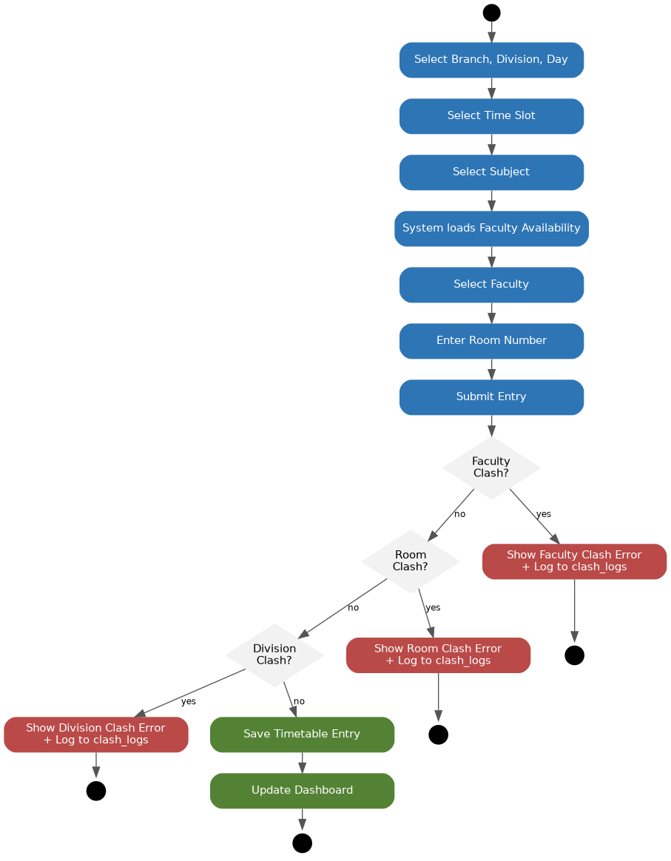
Figure 4: Activity Diagram – Timetable Entry Creation
The step-by-step activity flow for creating one timetable entry, showing the sequential selection steps followed by the three chained clash-check decision points (faculty, room, division). A 'yes' branch at any decision point routes to an error-and-log activity and ends; only when all three checks return 'no' is the entry saved and the dashboard updated.

FIGURE 5
Referenced in: Chapter 4, Section 4.13
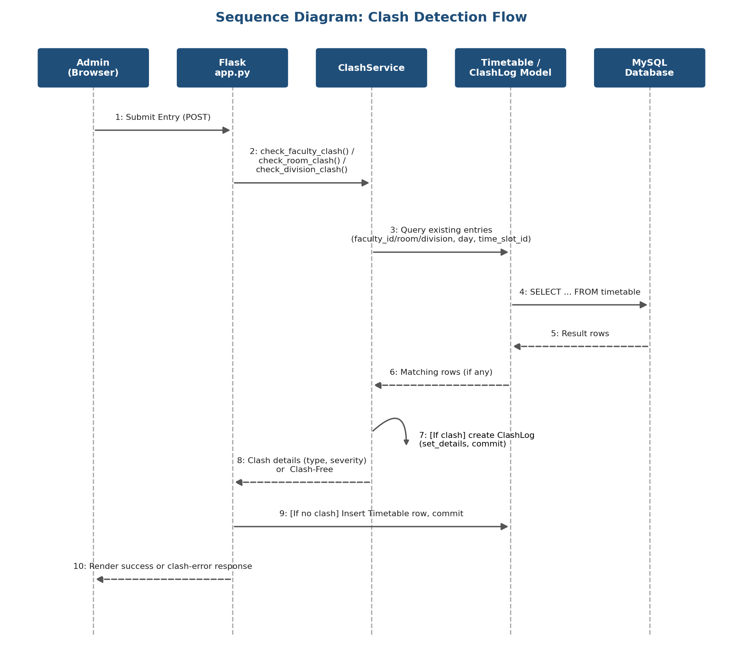
Figure 5: Sequence Diagram – Clash Detection Flow
Message flow across five lifelines — the Admin's browser, Flask's app.py, ClashService, the Timetable/ClashLog models, and the MySQL database — for a single submitted entry, from the initial POST request through the three clash queries, the conditional creation of a ClashLog row, and the final success or clash-error response.

FIGURE 6
Referenced in: Chapter 4, Section 4.14
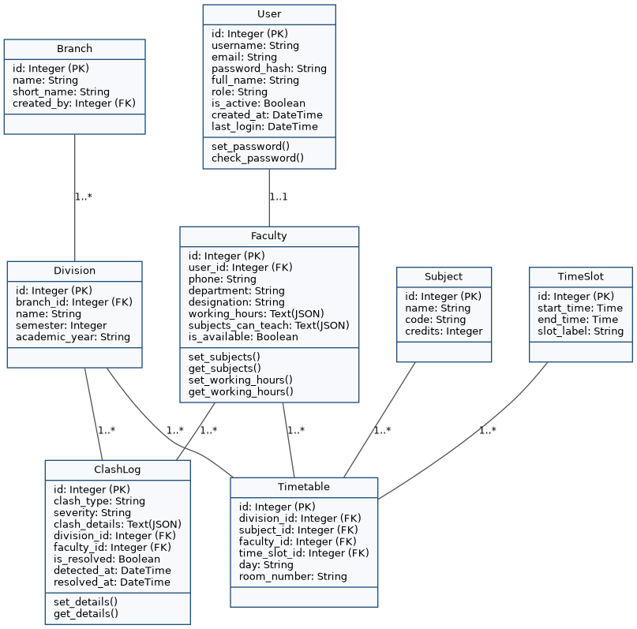
Figure 6: Class Diagram
The eight SQLAlchemy model classes with their key attributes and methods, as defined in models.py: User, Faculty, Branch, Division, TimeSlot, Subject, Timetable, and ClashLog, with the one-to-one User–Faculty relationship and the one-to-many relationships feeding into Timetable and ClashLog.

FIGURE 7
Referenced in: Chapter 4, Section 4.15
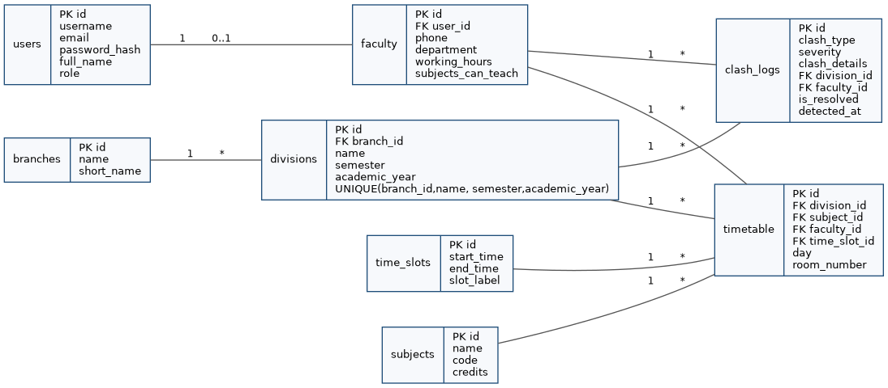
Figure 7: Entity Relationship (ER) Diagram
The eight database tables (users, faculty, branches, divisions, time_slots, subjects, timetable, clash_logs) with primary and foreign keys and cardinalities, including the composite uniqueness constraint on divisions(branch_id, name, semester, academic_year).

FIGURE 8
Referenced in: Chapter 4, Section 4.16
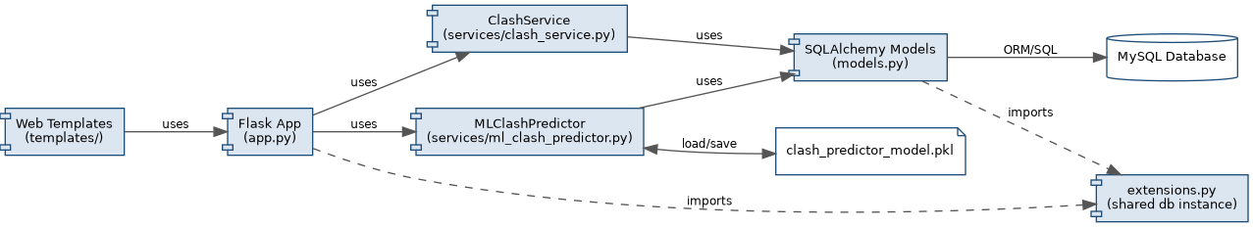
Figure 8: Component Diagram
The static component structure of the codebase: templates depend on the Flask app, which depends on ClashService and MLClashPredictor, which in turn depend on the shared SQLAlchemy models; app.py and models.py both share the single db instance from extensions.py; MLClashPredictor additionally reads and writes the persisted model file.

FIGURE 9
Referenced in: Chapter 4, Section 4.17
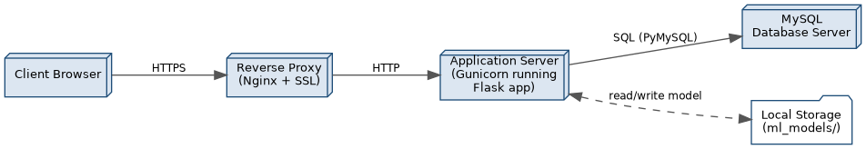
Figure 9: Deployment Diagram
The recommended production deployment topology: the client browser communicates over HTTPS with an Nginx reverse proxy, which forwards requests over HTTP to Gunicorn running the Flask application, which in turn communicates with the MySQL database server over SQL and reads/writes the locally stored ML model file.

FIGURE 10
Referenced in: Chapter 4, Section 4.18
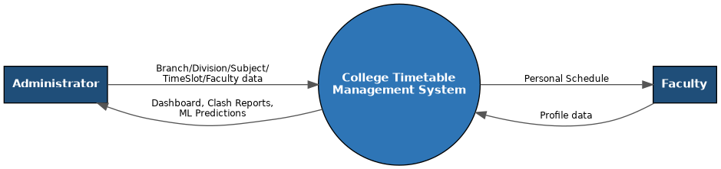
Figure 10: Data Flow Diagram – Level 0 (Context Diagram)
The system represented as a single process, with the Administrator and Faculty as the two external entities exchanging master data and profile data for dashboards, clash reports, ML predictions, and personal schedules.

FIGURE 11
Referenced in: Chapter 4, Section 4.19
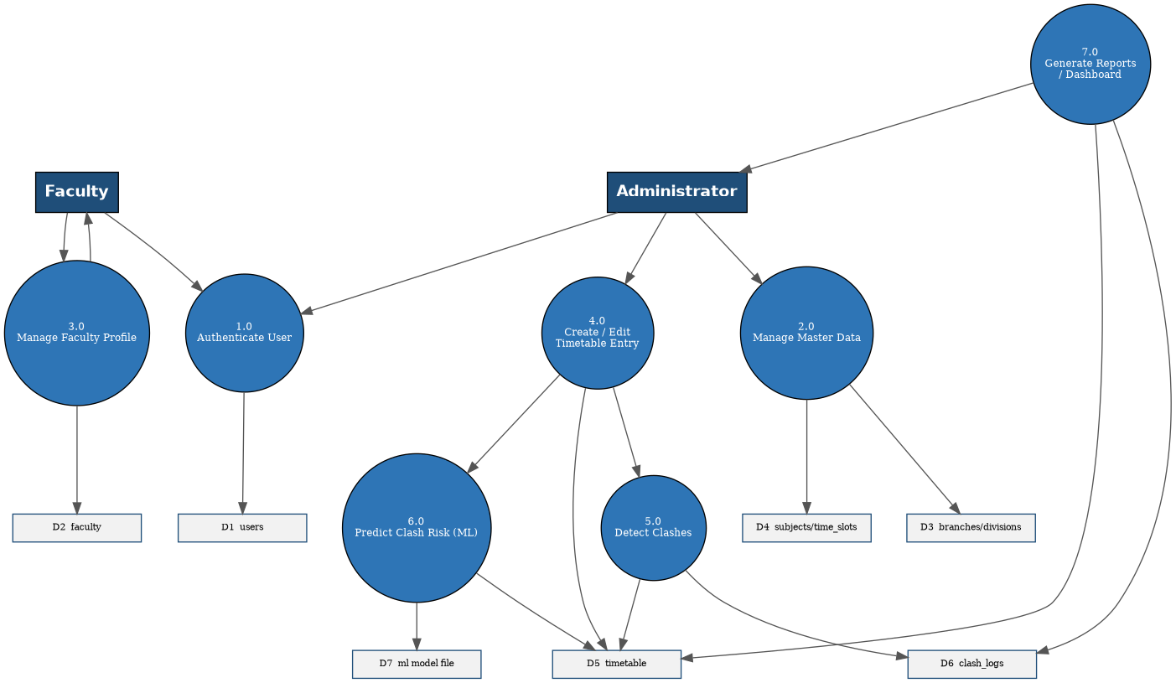
Figure 11: Data Flow Diagram – Level 1
The context process decomposed into seven sub-processes (Authenticate User, Manage Master Data, Manage Faculty Profile, Create/Edit Timetable Entry, Detect Clashes, Predict Clash Risk, Generate Reports/Dashboard) and their seven associated data stores (D1–D7).

FIGURE 12
Referenced in: Chapter 4, Section 4.20
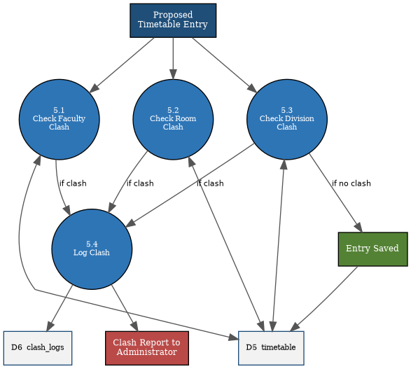
Figure 12: Data Flow Diagram – Level 2 (Expansion of Process 5.0)
The 'Detect Clashes' process expanded into its four sub-processes — Check Faculty Clash, Check Room Clash, Check Division Clash, and Log Clash — showing how a proposed entry either reaches the clash_logs store and a report to the Administrator, or is saved to the timetable store.

FIGURE 13
Referenced in: Chapter 6, Section 6.12 / 6.13
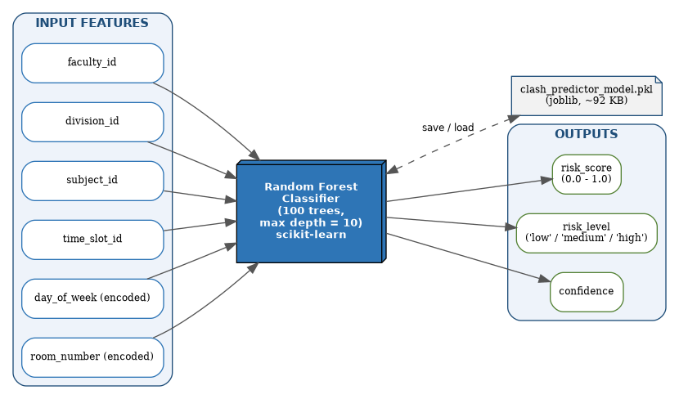
Figure 13: ML Model Architecture Diagram
The six input features encoded from a candidate timetable entry (faculty_id, division_id, subject_id, time_slot_id, encoded day-of-week, encoded room_number), the trained Random Forest Classifier (100 trees, maximum depth 10) that consumes them, its persisted model file, and the three outputs it produces: risk_score, risk_level, and confidence.

